The TRUTH about Drugs
You will link the use and abuse of specific drugs with their effects on the mind, body, goals, relationships, and society. During the video, you will confront personal beliefs and social norms concerning the use and abuse of legal and illegal drugs. You will be asked to think critically about why you hold your beliefs and defend your position to your peers.

Any predictions based on the title?

Analyze the video’s elements from 0:00 – 14:30 (San Diego, CA Teens)
- Setting/Culture

- Characters

- Conflict

- Climax (turning point)

- Reaction/Response

- Tone/Mood

How does the setting reinforce the characters?

Use the fishbone graphic organizer to represent the video segment.
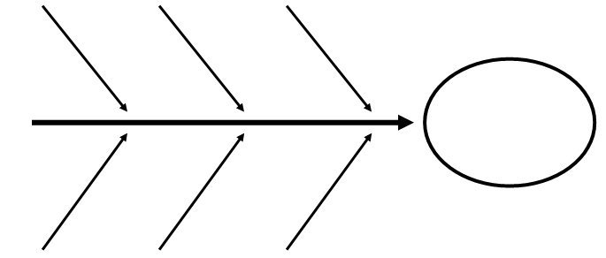
Analyze the video’s elements from 14:30 – 19:30 (Huffing)
- Setting/Culture
- Characters
- Conflict
- Climax (turning point)
- Reaction/Response
- Tone/Mood

Analyze the video’s elements from 19:40 – 31:00 (Seattle Teens)
- Setting/Culture

- Characters

- Conflict

- Climax (turning point)

- Reaction/Response

- Tone/Mood

How does the setting reinforce the characters?

Use the fishbone graphic organizer to represent the video segment.

